LGC v2 – Developer notes

Table of Contents
1. Introduction 1
2. Readers and writers 2
a. Readers 2
b. Writers and LGCObjectWriters 4
3. Measurements and instruments 4
4. Points and adjustable objects 6
5. New algorithms 7
6. Project and management 7
7. Next step 8

Introduction
A new version of LGC (Logiciel Général de Compensation) has been developed over the last few years. A completely different functional model and an improved stochastic model have been implemented, and the software has entirely been rewritten. New observation types have been developed to respond to new requirements such as: unlevelled stations making polar measurements; more flexibility when processing offset observations (lines and planes introduced); and processing camera sensors (BCAM). For a new accelerator line monitoring system a way to define assemblies of objects has also be implemented.
The stochastic model has also been modified to allow a better breakdown and parametrization of the instrument and observation errors; and a better error propagation. Special care has been taken testing the program. Unit and functionality tests have been added to assure future development, and an in depth comparison with the previous version has been made. Furthermore, the calculation structure has also been designed to allow new processing modules, such as a pre-processing model to calculate initial coordinate values, to be added more easily.
This document describes how the implementations is splitted and the goals of each sub project:
- ContributionsGenerators (part 5.)
- LGCAdjustableObjects (part 4.)
- LGCObjectsWritter (part 2.)
- LGCProject (part 6.)
- LGCProjectData (part 6.)
- LocalTransformations (part 5. Use in the Contributions Generators)
- LSCalculation (part 5.)
- Measurements (part 3.)
- Readers (part 2.)
- Writers (part 2.)

Readers and writers

Readers and writers are the link between the user and the software (calculation)

Readers

The main reader class is TReader. It manages the reading (read the file line by line). For that it uses ReaderBase to work on the stream (tokenize line, find comments and keywords…) and calls the specified parser depending on the keyword use to create the well object. The parsers are implemented in:
- AdjObjectsReader (points, frames)
- InstrumentReaders (instruments definition)
- OptionReader (all calculation and output options)
- MeasurementReaders and MeasurementsReaders_lgc1 for the observation definition.

LGC v2 must read old input file. Two readers have been developed. One for the lgc v2 format (https://wikis.web.cern.ch/wikis/display/SUS/LGC2+User+Guide ) and the other for the version 1 format (https://wikis.web.cern.ch/wikis/display/SUS/LGC+Guide+d+Utilisation ). Some key are identical between the two versions (in OptionReader, ReaderBase), and other are different (InstrumentReader and MeasurementReader for v2, MeasurementReader_lgc1 for the version1). At the end of the reading, the data are created (Points, instruments, ROM, and measurements are created/ instantiated).
Figure 4 represents the class diagram of the reader part for the lgc v2 format.

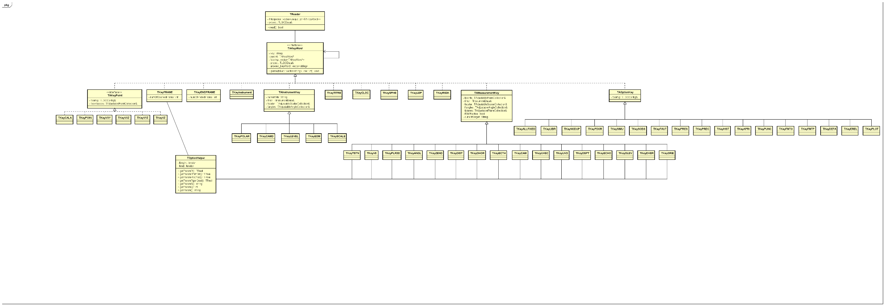 Figure 1: reader class diagram

Writers and LGCObjectWriters

Writers allow to write the results in formatted text files.
Two types of writers are implemented: one to write specific formatted output files (TxxxFileWritter) and the others to write specific parts of the file corresponding to the LGCObject (in LGCObjestWriters project), i.e. the measurements and the frames. Each measurements have a formatted output to fill a part in output files.
The main thing to know to understand how the data are written is that all LGC data are containing in a tree (hierarchy of frame in the input file). So each frame (node of the tree) has measurements, points… and all information of the data have a meaning in the frame. Its why all information are written/ managed by the TFRameWriter (in the function writeFRAMEAll() ).

Measurements and instruments

This part describe the data used for the calculation. The data can be defined in a measurement (value read on the staff/instruments) and the instrument. For more information about equations and measurements see EDMS document n⁰ 1465539 and the user guide to know how use it (https://wikis.web.cern.ch/wikis/display/SUS/LGC2+User+Guide ).
One instruments can have different type of observations. In the treatment we dissociate the instrument from the observations.
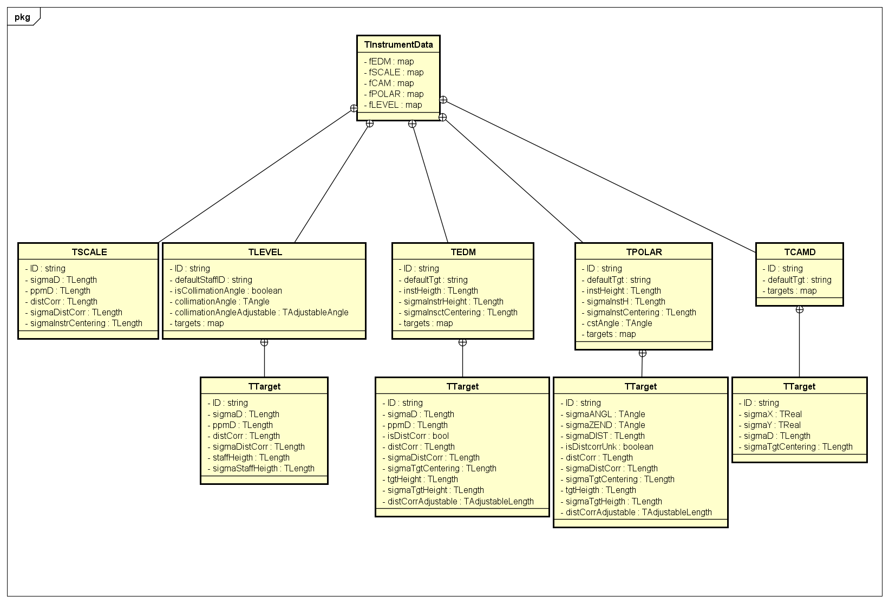
Figure 2: Instrument class diagram
Instrument or the couple instrument- target define the specification of the measurement, i.e. the precision of the measurement, the state of the instrument (height of the station for a total station or the collimation angle for a levelling instrument for example). Many targets can be defined for a same instrument. Each target redefined essentially the measurement precision. The instrument has a default target, but the target used can be modified during the measurement in the “observation definition” in the input file with the flag TRGT (user guide: https://wikis.web.cern.ch/wikis/display/SUS/LGC2+User+Guide ).
The observation (in a red square below) is the value given by the instrument between usually two points (the point stationed by the instrument and the point stationed by the target, which one we want to measure).
Each observation are stored in a class which represents a round of measurement, ROM, (in the blue square below). A ROM is defined by instrument position, each time the instrument move for a polar instrument or each time a different object (wire for ECHO, plane for DLEV…) is measured, a new ROM is created. The observations of a ROM allow to determine (during the least square) some internal unknowns due to the measurements (V0 for a total station, wire for ECHO…).
All of these information are used to fill input matrices for the least square, see the contribution generators (class which use observations equations with values from instruments, observations and points).

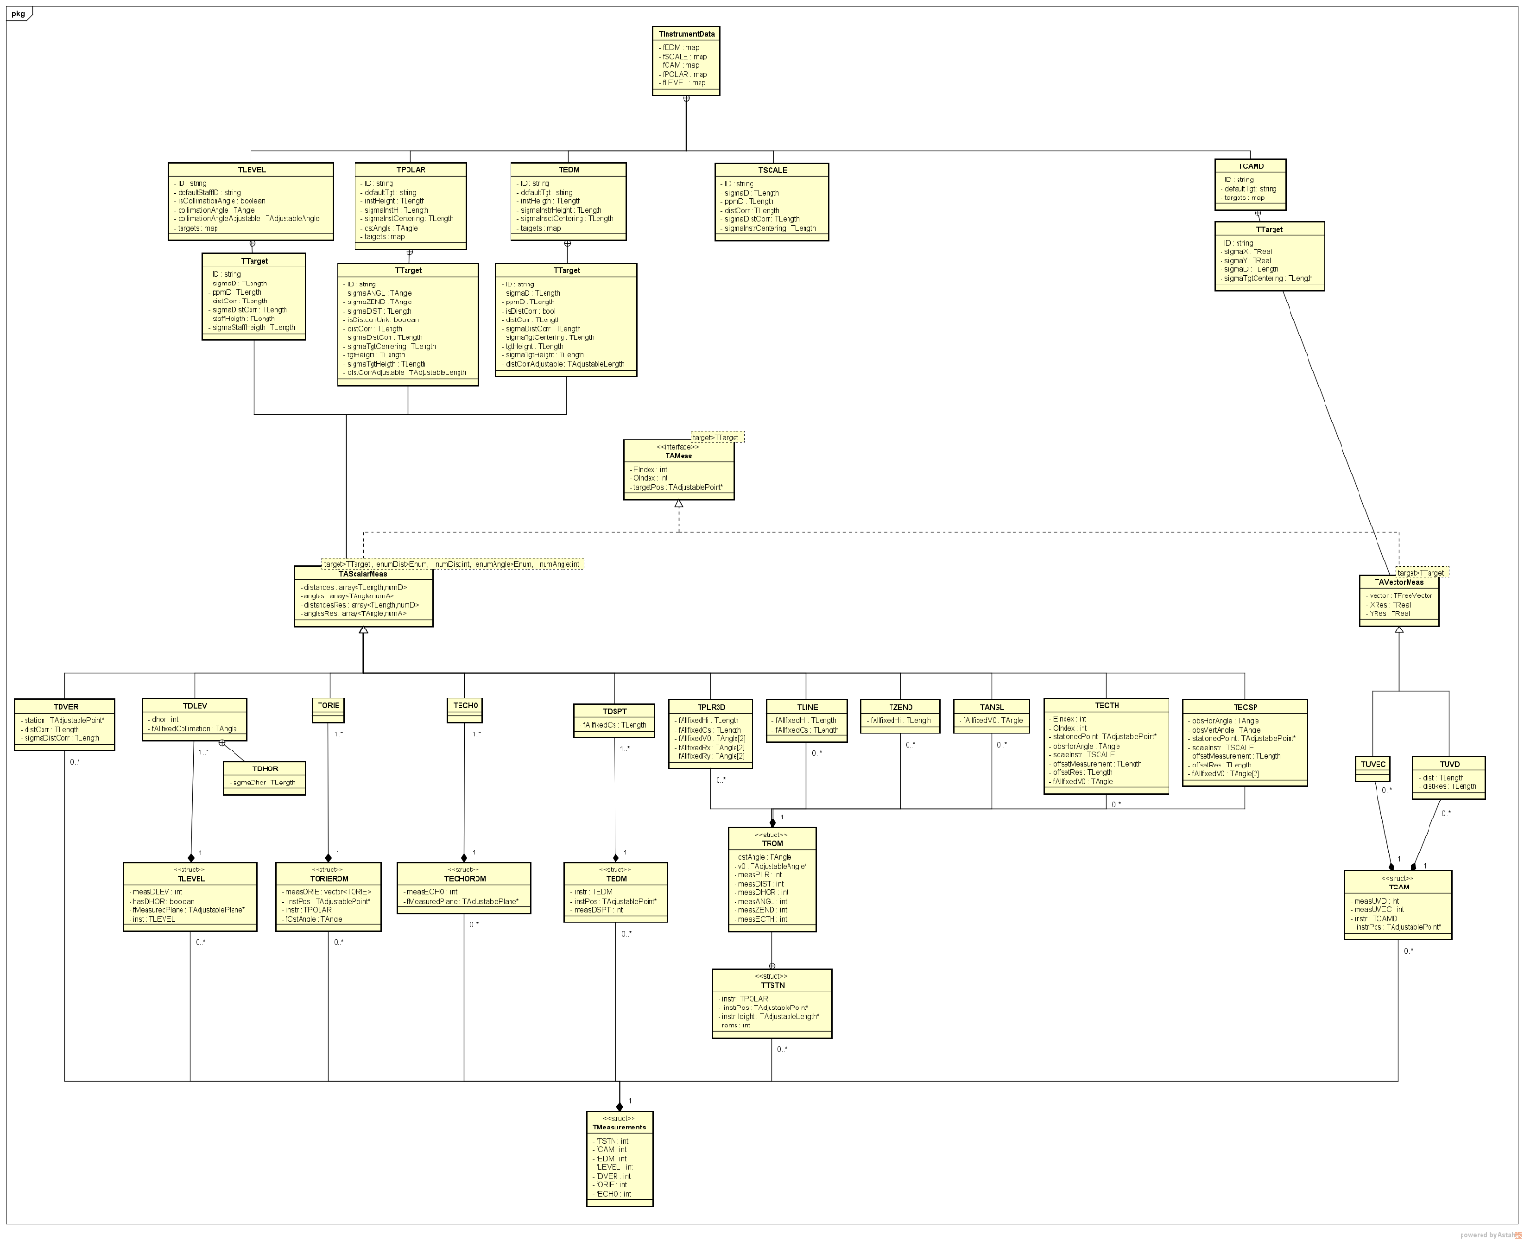
ROM
Observations
Figure 3: Observation class diagram

Points and adjustable objects

New objects have been implemented and integrated to the SurveyLib: the adjustable objects. Some objects have been overwritten for LGC v2: LGCAdjustableLine, LGCAdjustablePlane and LGCAdjustablePoint. Adjustable object are specific class to describe object use as unknowns in a least square process.
In least square we need mainly to have:
- The provisional value (initial value, which can be approximated)
- An estimated value (new value after n iterations)
- A correction (how the value is changing between each iteration)
- Sigma a priori
- Sigma a posteriori (estimated precision, covariance…)
- Indices (to know matrix position)
- Its place in the tree

New algorithms

New least squares solution have been implemented to solve the new non-linear equations, and the new unknown model. The solution calculation are stored in the SurveyLib. All mathematics are defined in EDMS document n⁰1475972.
In LGC2, a specific design pattern has been used to be able to integrated easier different other algorithms. LGC2 create and fill the input matrices using the contribution generators (TContributionGenerators, TPointTransformer), update matrices between each iteration and extract results (TLSMatrixExtractor). Specific treatment are also implemented to simulate data (TLSSimulation), run free constraint network (TLibrCntrGenerator) or run a fixed network (TLSAllfixed).

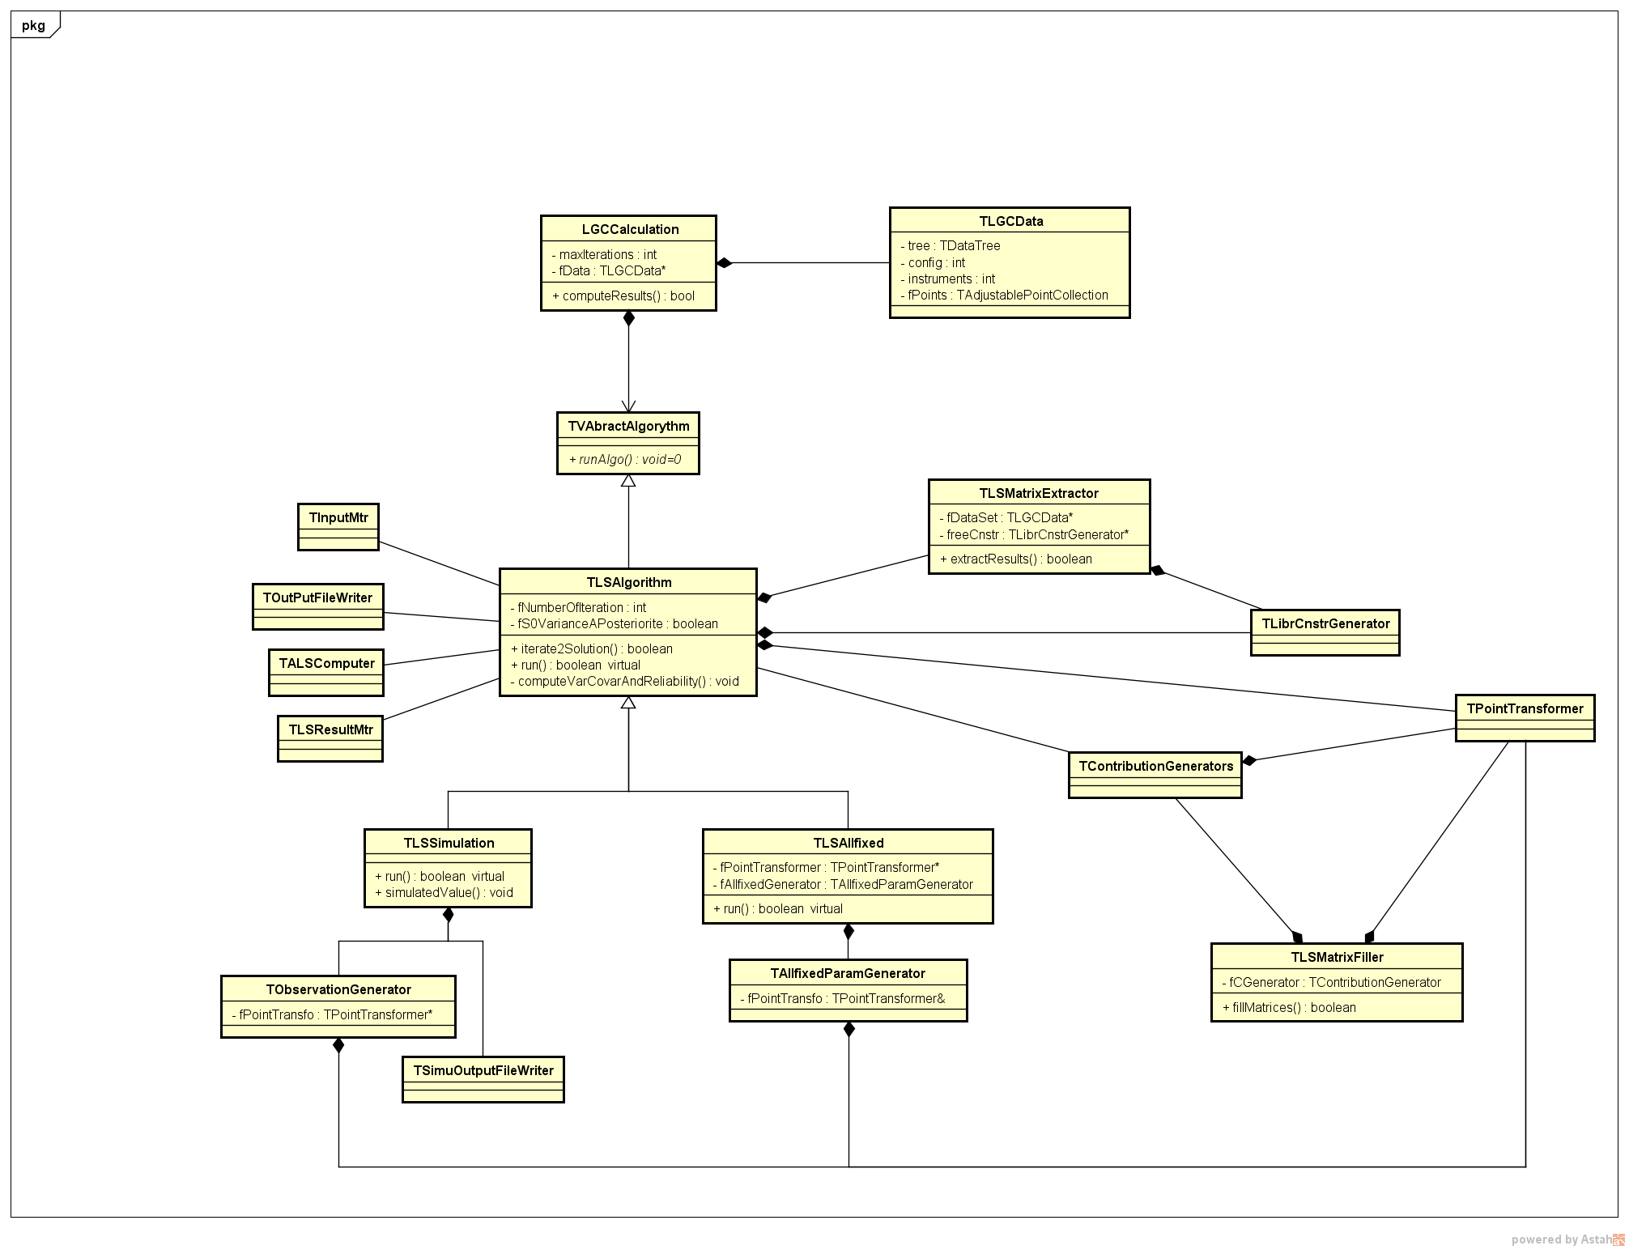
Figure 4: Class diagram for the algorithms part

Project and management
All data are store in TLGCData. The project is composed of:
- Set of instruments, defined by the input file (TInstrumentData)
- A tree (created with the frame), on each node points, measurements or node can be store. (tree, TTreeEntry)
- Statistics: number of observation, sigma 0 a posteriori… (TLGCStatistic)
- Calculation and output options (TLGCConfig)
- Log File (TFileLogger)

The project management is done in main.cpp and TLGCApp.

Next step
For the moment, the application can be used only in command line. A GUI is implementing.
Some real tests need to be done to find and fix bugs.

General processing of the observed measurements through a least squares algorithm
Unlevelled: not linked to the gravity

